 | ICCAUA Proceedings Journal  Proceedings of the international conference of contemporary affairs in architecture and urbanism-ICCAUA  Volume 9 (December 2026), Pages xxx–xxx  Journal homepage: https://journal.iccaua.com/ |  | 
DOI: https://doi.org/10.38027/ICCAUA2025XXXX

Title of Your Article
* ¹ Name Surname , ² Name Surname , ³ Name Surname
^{1, 2, & 3} Department of XXX, Faculty of XXX, University of XXX, City, Country
⁴ Department of XXX, Faculty of XXX, University of XXX, City, Country
¹ E-mail: xxx.xxx@xxx.xxx , ² E-mail: xxx@xxxx , ³ E-mail: xxxxx@xxxx , ⁴ E-mail: xxx@xxxx
¹ ORCID: https://orcid.org/0000-zzzz-zzzz-zzzz , ² ORCID: https://orcid.org/0000-zzzz-zzzz-zzzz , ³ ORCID: https://orcid.org/0000-zzzz-zzzz-zzzz ,
⁴ ORCID: https://orcid.org/0000-zzzz-zzzz-zzzz
 |  | Abstract
Received: xx xx 2026  Revised: xx xx 2026  Accepted: xx xx 2026  Available online: xx xx 2026  Copyright © 2026 by the author(s). All rights reserved.  This article is published under an open-access model and is made available in accordance with the terms of the Creative Commons Attribution 4.0 International Licence (CC BY).    The publisher maintains a neutral stance concerning jurisdictional claims in published maps and institutional affiliations.  This article has been selected and peer-reviewed for publication in this journal as part of the 9th International Conference of Contemporary Affairs in Architecture and Urbanism, held on 7–8 May 2026 in Istanbul, Türkiye. |  | xxxxxxxYour abstract should not exceed more than 150 words. It should be developed in such a way that to highlight the aim, important aspects of the study, methodologies, principal results, major conclusions and its contributions to the field. Author names should be written as full. Abbreviations or shortened names are not acceptable. Your certificate will be distributed accordingly. It is required for the authors to submit their abstracts in a Microsoft word .doc format. It is required for the authors to submit their abstracts exactly based on the given template. Academic Title should be added before the name of each individual author. Academic Title could be (B.S., B.A., M.A., Ph.D. Candidate, Dr.). Make sure to copy and paste your email address. Our experience shows that typing the email address may lead to entering the wrong address. Make sure to add the email address that you are using permanently. The Font style of the text should be “Calibri (Body) size 10”xxxxx.  Keywords: Keyword; Keyword; Keyword; Keyword, Keyword.

1. Introduction
Situate the reader within current scholarship, clearly identifying the unresolved theoretical, methodological or empirical lacuna your study tackles. State explicit objectives or research questions, explain why the gap matters in broader disciplinary debates, and preview how your work advances understanding. Heading Guidelines should be as below:

1. Introduction
1.1 XX
1.1.1 YYY
2. Materials and Methods
2.1 YYY
2.1.1 YYY
3. Results
3.1 ZZZ
3.1.1 ZZZ
4. Discussion
4.1 XXX
4.1.1 XXX
5. Conclusions
Acknowledgements
Funding, Conflicts of Interest
Data Availability Statement
Institutional Review Board Statement
CRediT Author Statement
References
✅ Keep headings brief yet descriptive for clarity.
✅ Maintain consistent capitalisation across all headings.
✅ Avoid overly long headings; if needed, break them into smaller logical parts.
2. Materials and Methods
Describe data sources, sampling, instruments and analytical techniques with enough detail to enable replication, emphasising any innovative protocols or mixed-method designs that strengthen validity. Justify methodological choices by linking them to the stated research gap and by explaining how they enhance originality.

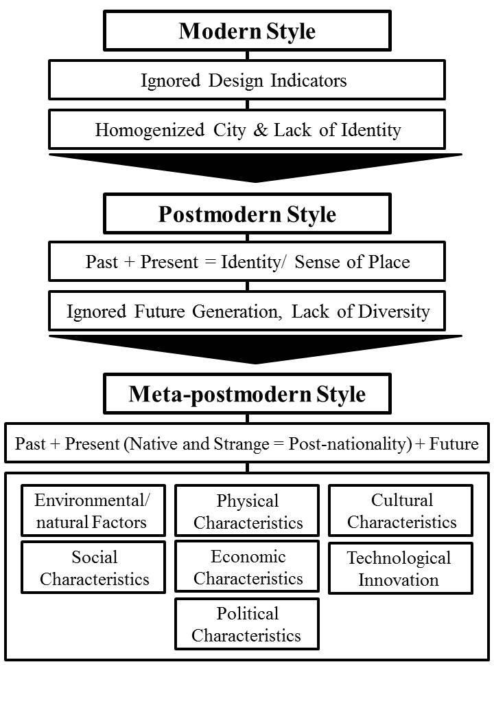
Figure 1. Structure of the Study (Developed by the Authors).

✅ All figures must be inline with the text, centred, and directly relevant to the theoretical contribution of the article.
✅ All figures must be developed by the authors and be sufficiently complex to be considered scientific figures.
✅ All figures must be high quality and developed using cutting-edge technologies and software.
✅ Figures should preferably be in black and white, drawn using AutoCAD or similar professional software to ensure precision.
✅ All figures must include clear, concise captions in English, indicating figure numbers and titles directly below each figure.
✅ Figures must be referenced in the main text before their appearance, using the format (Figure 1.), to ensure proper flow within the article.
✅ All figures must maintain consistent style and scale across the article to facilitate comparative analysis by readers.
✅ Figures containing data visualisation must include clear legends, units, and scales to allow accurate interpretation.
✅ Authors must retain the original editable files of the figures and submit them upon request to ensure print-quality resolution.
✅ Figures must not include any watermarks, logos, or unrelated decorative elements that may distract from their scientific purpose.

2.1 Integrating properties for heterogeneous roof environments
Consistently to the previous research, we calculate $σ_{DB,c}$ for a heterogeneous range of roofs surrounded by concrete, grass, or asphalt, essential to consider certain dielectric properties, specifically the Fresnel coefficients for the wall and the ground, as well as the roughness spectrum function.
In this respect, we assume both coherent and incoherent scattering contributions for which the argument of the second sinc function is restructured by considering the physical interpretation and simplification of the geometric terms involved.

$σ_{DB,c}=\left(\frac{k^{2}}{π}\right)A_{w}^{2}{\left|ρ_{hh}\right|}^{2}{sinc}^{2}\left[{kl}_{w} sin\left(θ\right)sin\left(ϕ\right)\right] {sinc}^{2}{\left(\frac{\cos\left(θ\right)}{{kh}_{w}\sin^{2}\left(θ\right)\sin^{2}\left(ϕ\right)}\right)}^{*}$

Equation 1. Coherent and Incoherent scattering cross section for heterogeneous roofs.

2.2 Classical Radar equation for monostatic systems
By extension of rooftop analysis, we now consider monostatic geometry, which is illustrated in Figure 1 whereby the received signal power ${ P}_{r}$can be evaluated using the classical radar equation for monostatic systems, which expresses the received power by the radar as a function of the transmitted power ${ P}_{t}$, the antenna gain ${ G}_{ant}$, the wavelength λ, the range between the radar and the target R, the one-way medium losses $L_{t}$ (here, losses introduced by the system are neglected), and the Radar Cross-Section (RCS) as follows in Equation 2, implemented in a researcher by Lambrechts, W. and Saurabh S., 2017:

$P_{r}= \frac{P_{t} { λ}^{2}{ G}_{ant}^{2} σ}{{\left(4 π\right)}^{3}{ R}^{4 }L_{loss}^{2}} Equation 2. Radar equation$.

✅ Including relevant formulas enhances the technical rigor and reproducibility of your research."
✅ Quantitative data and equations help validate your findings and demonstrate methodological precision."
✅ Formulas provide a clear framework for readers to understand your work’s theoretical foundations."
✅ Original equations or adaptations of existing models highlight the novelty of your approach."
✅ Mathematical expressions bridge theory and application, strengthening your paper’s impact."
✅ Well-defined formulas allow peers to replicate or build upon your research with accuracy."
✅ Statistical or analytical equations anchor your conclusions in measurable evidence."
✅ Even simple quantitative models can elevate your work’s credibility and clarity."

3. Results
Present findings logically—often from most to least novel—using tables or figures only where they add clarity. Highlight results that directly answer the research questions and demonstrate how they extend, refine or challenge existing theories.

Table 1: Comparative objective indicators of indoor and outdoor spatial conditions across housing cases A, B, C, and D.
Study case | A | C | D | B
 | 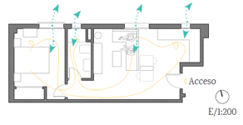 | 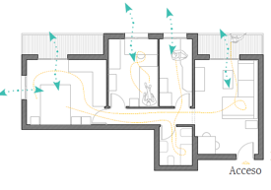 | 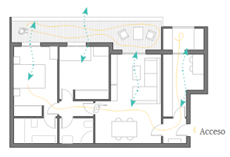 | 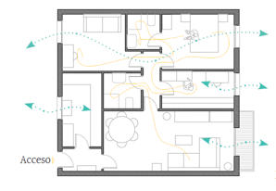
Neighbourhood  Height | Haza del Campillo  B+4 | Molinillo  B+5 | Torre del Mar  B+6 | Los Viveros  B+2
Orientation | North | North | Northeast | East
S_{i} (m2)  Indoor surface area | 40 | 48 | 67 | 70
Number of rooms (N) | 1 | 2 | 2 | 3
S_{o} (m2)  Outdoor surface area | - | 8 | 15 | 2.7
Number of balconies  Number of terraces | -  - | -  2 | 1  - | -  1
Number of residents (R) | 2 | 3 | 2 | 2
S_{i}/R (m2) | 20 | 16 | 33 | 35
N/R | 0.50 | 0.66 | 1.00 | 1.50
S_{o}/R | 0.00 | 2.66 | 7.50 | 1.35
Resident age | 26 – 27 | 49 – 51 – 23 | 34 – 27 | 24 – 27
Number of residents in WFM | 2 | 1 | 0 | 1
Pop-up office | Living room | Living room | - | Bedroom
Number of residents exercising | 2 | 1 | 2 | 1
Exercise space | Living room | Bedroom | Terrace / Bedroom | Living room

✅ All tables must be inline with the text, centred, and directly relevant to the theoretical contribution of the article.
✅ All tables must be created by the authors and be sufficiently detailed to be considered scientific tables.
✅ All tables must be high quality and developed using cutting-edge technologies and software.
✅ All tables must include clear, concise captions in English, indicating table numbers and titles directly above each table.
✅ Tables must be referenced in the main text before their appearance, using the format (Table 1:), to ensure proper flow within the article.
✅ All tables must maintain a consistent style, font, and formatting throughout the article to ensure a professional appearance.
✅ Tables presenting data must include clear units, column and row headings, and explanatory footnotes if necessary to ensure accurate interpretation.
✅ Authors must retain the original editable files of the tables and submit them upon request to ensure print-quality resolution.
✅ Tables must not include any unnecessary colours, shading, or decorative elements that may distract from their scientific purpose.

4. Discussion
Interpret the results in relation to prior studies, explaining how they close (or re-frame) the identified gap and what fresh avenues they open for scholarship or practice. Address limitations candidly and suggest future research that would build upon the article’s contribution.

Table 2: Material-Specific Reflection and Dielectric Metrics in Concrete Settings.
 | PV | Greenhouses | Trucks | Built | Shore**
$$B_{w}$$ | $$ε_{r, PV}=12.0-j 0.8$$ | $$ε_{r, Plast}=2.8-j 0.15$$ | $$ε_{r, Trucks}=15.0-j 1.0$$ | $$ε_{r, Built}=4.5-j 0.3$$ | $$ε_{r, Shore}=2.8-j 0.1$$
$$G_{s}$$ | $$ε_{r, Concrete}= 5.5-j 0.25$$
$$R_{⊥}\left(θ_{avg}\right)$$ | −0.42 ⁽¹⁾, −0.47 ⁽²⁾,  −0.47 ⁽³⁾ | −0.47 ⁽¹⁾, −0.46 ⁽²⁾,  −0.44 ⁽³⁾ | −0.41 ⁽¹⁾, −0.46 ⁽²⁾,  −0.435 ⁽³⁾ | −0.463 ⁽¹⁾, −0.45 ⁽²⁾,  −0.435 ⁽³⁾ | −0.251 ⁽¹⁾, −0.45 ⁽²⁾,  −0.433 ⁽³⁾
$$R_{∥​}\left(θ_{avg}\right)$$ | 0.34 ⁽¹⁾, 0.47 ⁽²⁾,  0.34 ⁽³⁾ | 0.34 ⁽¹⁾, 0.36 ⁽²⁾,  0.36 ⁽³⁾ | 0.36 ⁽¹⁾, 0.36 ⁽²⁾,  0.352 ⁽³⁾ | 0.354 ⁽¹⁾, 0.35 ⁽²⁾,  0.352 ⁽³⁾ | 0.252 ⁽¹⁾, 0.35 ⁽²⁾,  0.337 ⁽³⁾
$$R_{⊥}W\left(θ_{w}\right)$$ | −0.55 ⁽¹⁾, −0.59 ⁽²⁾,  −0.55 ⁽³⁾ | −0.26⁽¹⁾, -0.31 ⁽²⁾,  -0.29 ⁽³⁾ | −0.59⁽¹⁾, −0.59 ⁽²⁾,  −0.587 ⁽³⁾ | −0.357 ⁽¹⁾, −0.42 ⁽²⁾,  −0.42 ⁽³⁾ | −0.251 ⁽¹⁾, −0.251 ⁽²⁾,  −0.288 ⁽³⁾
$$R_{∥}W\left(θ_{w}\right)$$ | 0.48 ⁽¹⁾, 0.47 ⁽²⁾,  0.46 ⁽³⁾ | 0.26 ⁽¹⁾, 0.28 ⁽²⁾,  0.24 ⁽³⁾ | 0.47 ⁽¹⁾, 0.47 ⁽²⁾,  0.469 ⁽³⁾ | 0.312 ⁽¹⁾, 0.33 ⁽²⁾,  0.35 ⁽³⁾ | 0.252 ⁽¹⁾, 0.252 ⁽²⁾,  0.287 ⁽³⁾
0° - 10° ⁽¹⁾ | 0.67 m²$≈$ −1.74 dB | 0.62 m²$≈$ −2.08 dB | 0.19 m²$≈$ −7.21 dB | 0.19 m²$≈$ −8.87 dB | 0.19 m²$≈$ −8.23 dB
11° - 45° ⁽²⁾ | 0.95 m²$≈$ −0.22 dB | 0.62 m²$≈$ −2.08 dB | 0.74 m²$≈$ −1.30 dB | 0.62 m²$≈$ −2.76 dB | 0.12 m²$≈$ −9.2 dB
0° - 45° ⁽³⁾ | 1.32 m²$≈$ 1.21 dB | 0.68 m²$≈$ −1.67 dB | 0.62 m²$≈$ −2.07 dB | 0.62 m²$≈$ −3.47 dB | 0.14 m²$≈$ −8.5 dB

Complementary to the Material-Specific Reflection and Dielectric Metrics tables, insights into the behavior of materials and systems under different conditions are illustrated as follows in Figure 4: abrupt transitions, cycling between 0 and 180 degrees at these null frequencies with a consistent phase lag of phase response, compared to sample frequency, and how systems or filters respond to varying frequencies:

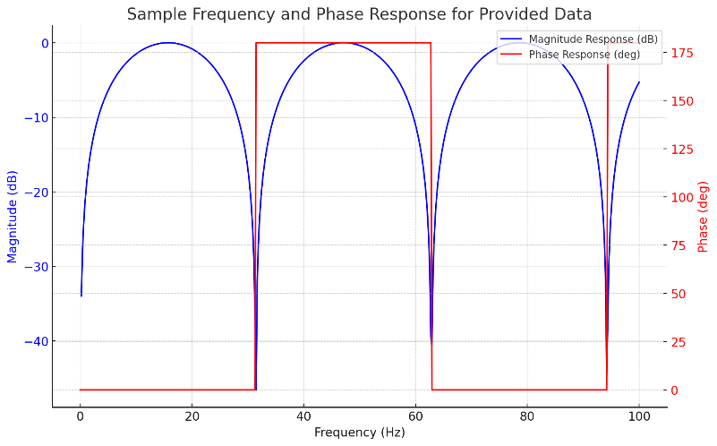
Figure 4. Periodic Nulls, minimal -40 dB, and Resonant Characteristics: dynamic analysis vs. static properties.

Related to domain insights, the Figure 5 focuses on the Smooth Low-Pass filter response, revealing how materials and systems behave across a spectrum of frequencies, highlighting its response decreasing gradually from 0 dB at low frequencies to approximately - 20 dB at 10 kHz; this is essential in hardware with a highly frequency-dependent behaviour (such as resonance, attenuation, and phase shift), henceforth directly impacting performance; from a theoretical perspective, Figure 6, lastly, highlights the magnitude response decreasing smoothly from 0 dB to about -20 dB at 100 Hz, similar to the low-pass characteristics observed in the previous plot, i.e. the phase response decreases from 0 degrees to around -80 degrees at 100 Hz. By incorporating these translations of such properties into real-world applications, we further bridg a further gap between academic material metrics and their optimizing architecture.

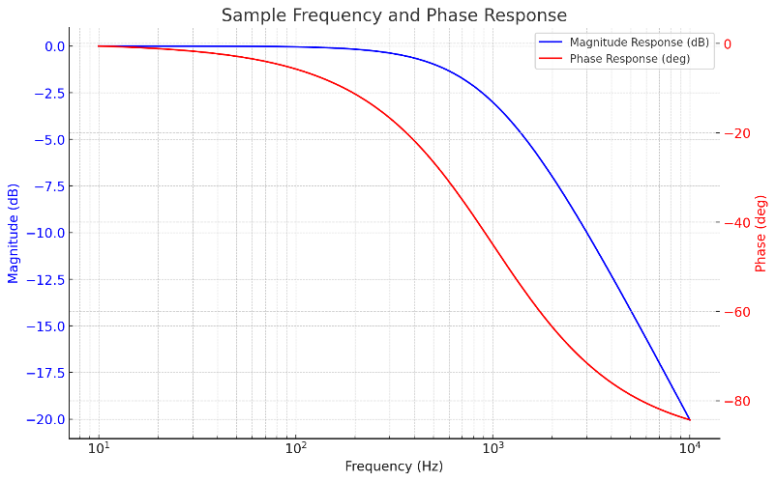
Figure 5. Sample frequency and phase response.
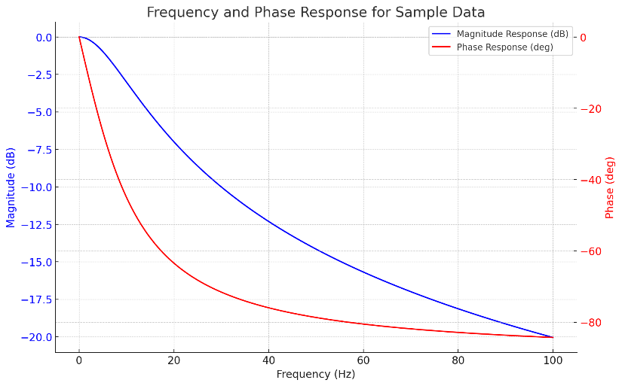
Figure 6. Frequency and phase response for sample data.

4.1. Comparative Analysis of Structural Keypoints in Photovoltaic, Greenhouse, and Built Environments
The comparative analysis of keypoints extracted using the ORB (Oriented FAST and Rotated BRIEF) algorithm across photovoltaic (PV) systems, greenhouses, and built environments provides valuable insights into the structural and spatial characteristics of these diverse settings. Wit this in mind, the uniform distribution of keypoints in PV systems, spanning a broad angular range (0 to 800 degrees), reflects the algorithm’s ability to capture the relatively consistent and orderly layout of these structures.
In contrast, the denser concentration of keypoints in greenhouses, particularly in specific angular ranges (400 to 800 degrees), underscores ORB’s sensitivity to the repetitive, modular design of greenhouse frameworks discarding wrong matching points (Huang, C. et al., 2014); in corresponding terms, this indicates that ORB excels in environments where structural regularity is prominent, effectively highlighting key features.
Nonetheless, this performance also suggests that while ORB is highly effective in detecting keypoints in such repetitive patterns, it may not fully capture more subtle variations within these environments. This limitation is not necessarily a drawback but rather an opportunity to refine and enhance the algorithm’s application in these contexts; with a practical implication, when applied to built environments, which exhibit more architectural complexity and diversity, ORB successfully identifies distinct keypoint patterns, demonstrating its versatility. Yet, the algorithm’s sensitivity to structural complexity might lead to less consistent keypoint detection in these more varied settings.
Overall, while ORB performs admirably across different environments, particularly in those with clear and repetitive structures, there is room for further optimization. These findings suggest that the integration of ORB with complementary techniques could enhance its robustness, particularly in more complex environments. Such enhancements would make ORB a more universally applicable tool, capable of providing even more reliable and comprehensive analysis across a wide range of structural settings.
This critical, yet constructive, assessment of ORB’s capabilities highlights its strengths while also pointing in Figure 7 (a) towards future improvements that could further its utility in structural monitoring and environmental assessment along with its Spline Interpolation (b).

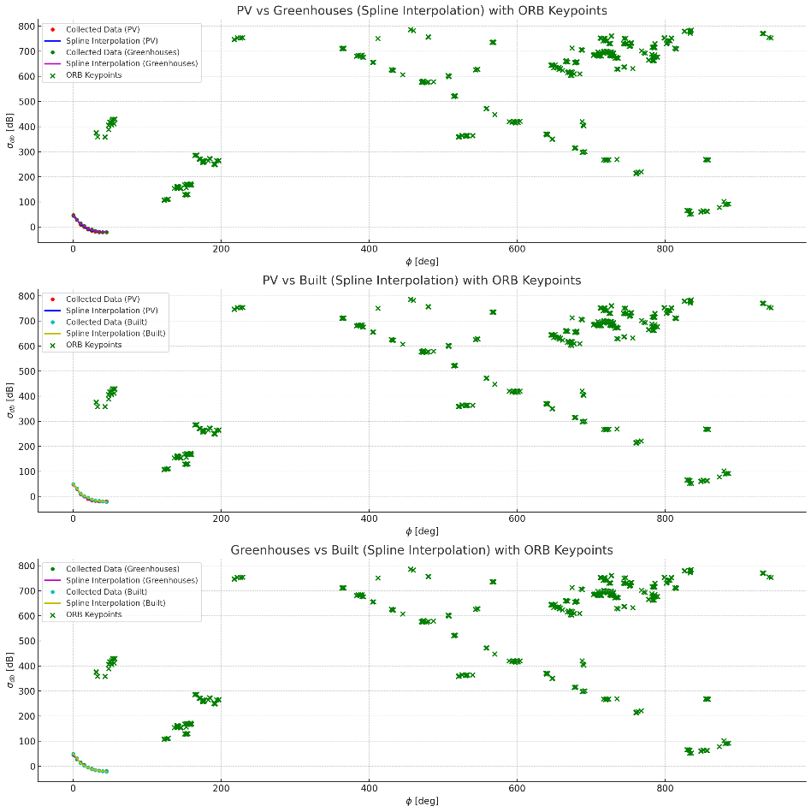
Figure 7 (a). PV vs Greenhouses with ORB Keypoints.

Analogously, Figures 8 (a) presents across a range of angles, the structural differences between PV systems and built structures whilst for (b), a comparative analysis of keypoints is detected in photovoltaic (PV) systems versus built environments using the ORB algorithm.

Figure 8 . PV vs Built with ORB Keypoints.

5. Conclusions
Recapitulate the main insights and their significance without restating data. Emphasise original contributions to theory, policy or professional practice, and articulate clear, evidence-based recommendations or conceptual advances.

Authors must add the following sections after the Conclusion and before the References in their full paper: Acknowledgements, Funding, Conflicts of Interest, Data Availability Statement, Institutional Review Board Statement, CRediT Author Statement. You can remove the blue lines from the template and provide relevant information.

Acknowledgements
Briefly recognise individuals or organisations that offered non-authorial support—such as technical assistance, language editing or access to proprietary data—while avoiding effusive language or professional titles.

Funding
State all sources of financial support and relevant grant numbers. If no external funding was obtained, declare: “This research received no specific grant from any funding agency in the public, commercial or not-for-profit sectors.” For more information, please see Manuscript Structure : https://www.iccaua.com/page/paper-guidelines

Conflicts of Interest
Disclose any financial, personal or institutional relationships that could be perceived to influence the work. If none exist, write: “The author(s) report no conflicts of interest.” For more information, please see Manuscript Structure : https://www.iccaua.com/page/paper-guidelines

Data Availability Statement
Specify where underlying data, code or other research materials can be accessed, under what conditions, and in what format, so that readers can verify and build upon the study. For more information, please see Manuscript Structure : https://www.iccaua.com/page/paper-guidelines

Institutional Review Board Statement
For studies involving humans or animals, provide the ethics committee name, approval number and date, confirming adherence to the Declaration of Helsinki (or equivalent). If not applicable, state so explicitly. For more information, please see Manuscript Structure: https://www.iccaua.com/page/paper-guidelines

CRediT Author Statement
Detail each author’s individual contribution using the 14 CRediT roles (e.g., Conceptualisation; Methodology; Writing – original draft; Writing – review & editing). Conclude with: “All authors have read and approved the final manuscript.” For more information, please see Manuscript Structure: https://www.iccaua.com/page/paper-guidelines

Reference list (APA 7th edition)
Bills, T. S., Twumasi-Boakye, R., Broaddus, A., & Fishelson, J. (2022). Towards transit equity in Detroit: An assessment of micro-transit and its impact on employment accessibility. Transportation Research Part D: Transport and Environment, 109, 103341. https://doi.org/10.1016/j.trd.2022.103341
Bunten, D. M., Preis, B., & Aron-Dine, S. (2024). Re-measuring gentrification. Urban Studies, 61(1), 20–39. https://doi.org/10.1177/00420980231173846
Caggiano, H., Kocakuşak, D., Kumar, P., & Tier, M. O. (2023). U.S. cities’ integration and evaluation of equity considerations into climate action plans. npj Urban Sustainability, 3(1), 50. https://doi.org/10.1038/s42949-023-00129-6
García-García, A., Cuesta-Valero, F. J., Miralles, D. G., Mahecha, M. D., Quaas, J., Reichstein, M., Zscheischler, J., & Peng, J. (2023). Soil heat extremes can outpace air-temperature extremes. Nature Climate Change, 13, 1237–1241. https://doi.org/10.1038/s41558-023-01812-3
Grabowski, Z. J., McPhearson, T., & Pickett, S. T. A. (2023). Transforming US urban green-infrastructure planning to address equity. Landscape and Urban Planning, 229, 104591. https://doi.org/10.1016/j.landurbplan.2022.104591
Guan, Y., Yan, J., Shan, Y., Zhou, Y., Hang, Y., Li, R., Liu, Y., Liu, B., Nie, Q., Bruckner, B., & Hubacek, K. (2023). Burden of the global energy-price crisis on households. Nature Energy, 8, 304–316. https://doi.org/10.1038/s41560-023-01209-8
Mouratidis, K. (2024). Time to challenge the 15-minute city: Seven pitfalls for sustainability, equity, livability and spatial analysis. Cities, 153, 105274. https://doi.org/10.1016/j.cities.2024.105274
Rouhana, F., Zhu, J., Chacon-Hurtado, D., Hertel, S., & Bagtzoglou, A. C. (2024). Ensuring a just transition: The electric-vehicle revolution from a human-rights perspective. Journal of Cleaner Production, 462, 142667. https://doi.org/10.1016/j.jclepro.2024.142667
Sharifi, A. (2023). Resilience of urban social-ecological-technological systems (SETS): A review. Sustainable Cities and Society, 99, 104910. https://doi.org/10.1016/j.scs.2023.104910
Zhai, W., Bai, X., Shi, Y., Tang, J., & Shi, Y. (2025). Low-cost sensor desert and equity across US cities. Environment and Planning B: Urban Analytics and City Science (advance online publication). https://doi.org/10.1177/23998083251325593

✅ Record each entry in APA 7th edition style using UK spelling conventions.
-Select sources for citation solely from Web of Science Core Collection via https://www.webofscience.com/wos/woscc/basic-search.
✅ Cite articles published within the last four calendar years.
✅ Include only peer-reviewed research articles or systematic reviews; omit editorials, letters and conference abstracts.
✅ Choose papers directly aligned with the manuscript’s scope, title and research questions.
✅ Prioritise journals ranked Q1 or Q2 in Journal Citation Reports to enhance citation quality.
✅ Favour primary empirical work or rigorous meta-analyses that close an identified knowledge gap.
✅ Cap self-citations at 2 % of the total reference list to preserve objectivity.
✅ Provide a full DOI hyperlink for every citation in the form https://doi.org/xxxxxxx.
✅ Supply complete bibliographic details—authors, year, article title, journal title (in full), volume, issue, page range or article number.
✅ Enter and format all references with recognised citation-management software (EndNote, Zotero, Mendeley or Word’s Referencing tool).
✅ Conduct a duplicate-reference check to ensure each source appears only once.
✅ Cross-verify in-text citations and the reference list for one-to-one correspondence.
✅ Arrange entries in alphabetical order by first author’s surname, using hanging indentation and double spacing.
✅ Avoid citing predatory or non-indexed journals, even if they appear in secondary databases.

Authors must add the following sections after the Conclusion and before the References in their full paper: Acknowledgements, Funding, Conflicts of Interest, Data Availability Statement, Institutional Review Board Statement, CRediT Author Statement.

